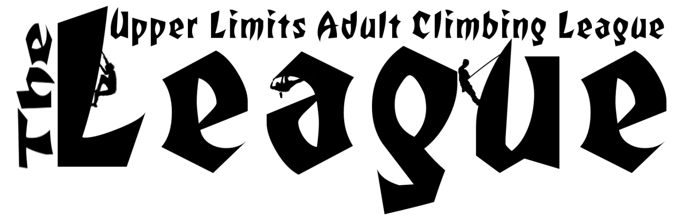

Upper Limits Adult Climbing League or “The League” is an informal, casual league geared to get you psyched on climbing and training harder. This is also a great way to meet new people, find and meet new challenges, improve your mental and physical climbing, hone your climbing skills and most importantly, have a lot of fun pushing YOUR limits. Regardless if you are the next Chris Sharma or you have just started pulling on plastic, this league is for YOU. The league format is compatible with both Toprope and Lead climbers. We will be using a handicap system to create a fair yet competitive environment for all climbers, regardless of experience level. You can sign up with your friends and create your own team or simply sign up on your own and we will select your teammate for you from the league pool on a random unbiased basis. Best of all, there will be cash prizes to the winning teams!

Registration:
- League Season – Seven Weeks Long (only 6 Weeks Count towards your final score)
  - Starting Monday, Oct. 2nd and ending Sunday, Nov. 19th.
  - League climbing will take place at the Downtown and Maryland Heights facilities. There will be no League routes at Chesterfield.
  - A day pass or membership is still required to participate.
  - All participants will receive a League T-shirt!

- Signup
  - Due to the ability of each competitor to climb just 6 weeks (out of 7) without penalty, registration will close on the final day of week 2 – October 8th.
  - A $15 registration fee is due at the time of registration (tax not included).
  - Each climber must sign up through the Upper Limits online calendar, which is available at the front desk of Maryland Height or Downtown, as well as online at www.upperlimits.com. The following information is required:
    - Climbers name
    - Team name
    - Preferred T-Shirt size
    - Division – based on assessment of your own ability when signing up. Please be honest in your assessment. Remember, this is a ‘fun’ league and sandbaggers will be bumped accordingly.
    - Contact info – email & phone number (scores are e-mailed weekly)
    - Names of desired teammate (2 per team) – if you don’t have a partner, we can pair you with another climber.
RULES:
- Teams
  - 2 climbers per team
  - Climbers must be at least 18 years or older.
  - You can and should pick a team name. Duplicate and inappropriate team names will be addressed.
  - You can pick your team at the time of registration or we will pick your teammate for you. Once competition begins, you will not be allowed to switch teams.
  - Pairing with climbers of different divisions will have NO effect on your chances of winning (see division and handicap breakdown below).
  - You may climb any day of the week that you choose with/without your teammate. However, you can only submit one score card for the top five routes that you climbed during ONE climbing session (i.e. day).

- Handicap System
  - This system is designed to level the playing field so that regardless of your ability, you can still earn just as many points for a climb that is hard for you as a climber who is climbing a grade or two above or below you can for pushing their own limits.
  - Picking a Division – each climber must select a division that is represents the climbing grade that the climber can redpoint (complete WITH practice) but generally cannot onsight (complete with no practice or other help).
    - Doing 5 routes of this grade a night should feel next to impossible (but not for long hopefully)
    - If you are a 5.10 climber (or higher) , please also pick the letter grade associated with your core grade (i.e. 5.10a, 5.10b, 5.10c, or 5.10d).
  - Calculating Points – Climbing your division grade is worth 15pts per climb on top rope. You will either earn + 5pts for each increasing grade or – 5pts for each decreasing grade climbed. You can also earn a 20% point increase if you lead the route. For a better breakdown, see the chart below.
  - Bumping – if it is obvious that you should be climbing in a higher division, you will be bumped accordingly
    - We don’t want to invoke fear of being bumped, thus limiting your progression. However, if we know you as a climber or watch you/your score card throughout the season and notice that you should be in higher division, then you will be bumped into the appropriate category.
    - There will be no down grading of climbers. In other words, if you over assess your abilities, that will simply be all the more drive to progress as a climber.
    - If you are bumped, all of your past scores will also be bumped, meaning that you will earn less point per route then you originally anticipated.
    - The league administrator reserves the right to assess and alter your score as he sees fit and will do so in a fair and unbiased manner.

- Scoring
  - Your top 5 routes must be completed in a single day.
  - Points are earned for completing a route without falling or receiving any physical assistance from your belay (i.e. resting, leaning or pulling on the rope and/or holding/stepping on off-route holds).
  - The point value for each route is relative to the division you are in (see chart below).
  - You cannot climb the same route for points within a 3 week period. In other words, the routes submitted on week 1 cannot be climbed again for points until week 4.
  - Each climber will fill out their own scorecard and submit it by closing on Sunday (the league’s “week” will run Mon-Sun).
  - Your lowest scoring week will be thrown out. This means that only 6 of the 7 weeks will count towards your total score. This allows you the ability to miss 1 week without being penalized.

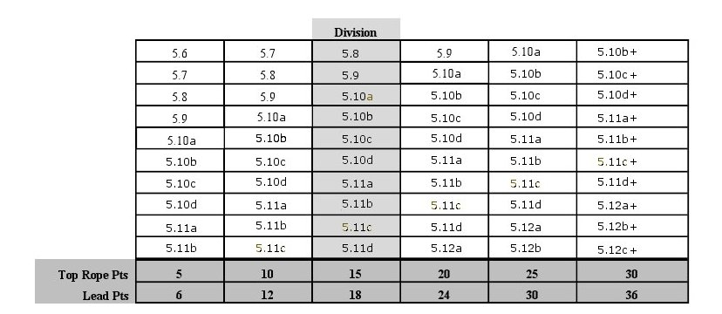

- Prizes
  - The first thing to remember is that this league is all about having fun and pushing your limits.
  - Upper Limits Gift Cards will be awarded to the TOP TWO TEAMS. The amount will be determined based off the number of people signed up for the League. So the more people in the League, the bigger the prize.
  - All participants will receive a League competitor T-Shirt.

